Title: | Door Control Module  SW Architecture 1.0

History
Issue status  (Index) | Maturity/Date  (draft/invalid/valid)  (dd-mmm-yyyy) | Author  Department | Check/Release  Department | Description
1.0 | Draft  04-0ct-20 | Marco Antonio Mares Mejía | Marco Antonio Mares Mejía | Creation of the document

Table of Contents
1 Purpose 3
2 Definitions and abbreviations 3
3 Realization constraints and targets 3
4 SW Functional Architecture 3
4.1 Table of functions 3
4.2 Table of functional Interfaces 4
4.3 Functional Interface 4
4.4 Functional Interaction 4
5 SW Physical Architecture 5
5.1 Physical Decomposition 5
5.2 Table of SW components 5
5.3 Table of Physical Interfaces 5
5.4 Physical Interfaces 6
5.5 Physical Interaction 6
5.6 Describe Dynamic Behavior 6
5.6.1 OS tasks 6
5.6.2 Interrupt Handling 6
5.6.3 Power Modes 7
5.7 Synchronization Mechanisms 7
6 Function to Physical Allocation 7
7 SW Requirements Allocation 8
8 SW Integration Plan 8
9 Functional Safety 8

Purpose
This document has been created as a demonstration to the students about to how to create a SW architecture from requirements.

Definitions and abbreviations
Definitions
Special Byte | Special byte received to change the baud rate 55h

Abbreviations
Only SW Architecture specific abbreviations.
References
N° | Document name | Reference
1 | SW Requirements | Act2.1_MaresMejia_MarcoAntonio.xls
2 | System Description | Proyecto_DoorControlModule.docx

Realization constraints and targets

Generic OEM Motor has requested a New ECU that will be used o their car to control doors on vehicle. This system will control DriverDoor, PassengerDoor, RearRight Door and RearLeft Door.
Main functionalities for the system include:
• Door Locking
• Window Control
• HW Diagnostics

SW Functional Architecture
Identify the functional behavior that will be implemented on Software.
Identify different SW functions with its corresponding interaction among them.
Identify and describe the signals and events used to share information among functions.

Table of functions
Function Name | Description
Determine DCU Button Press | Determines the button/switch pressed and type of pressing.
Control Door Operation | Dictates which Door will execute the Lock/Unlock operations and when this will happen.
Control RGB LED | Sets the sequence of the RGB LED representing the behavior of the Door solenoid.
Determine Door Lock Status | Determines if a Door is Locked or Unlocked.
Build CAN Frame | Assembles the CAN Frame which controls the remote modes of Doors and Windows.
Control Window Operation | Dictates which Window will execute the operations and when this will happen.
Control LED Bar | Sets the animation of the LED which represents the Window Position and Operation.
Determine Window Position | Detects the positions of the Windows.
Determine Vehicle Speed | Detects the actual Speed of the Vehicle.
Determine System Power Mode | Detects the actual Power Mode of the System.
Auto Lock While Driving | Closes the Doors after determining Vehicle Speed and System Power Mode.
Anti Pinch Event | Stops a Window Operation if an obstacle is detected.
HW Diagnosis | Sets the response for unwanted conditions.
Manage Errors | Dictates what to do after an error is detected.
Provide Manufacturing Info | Sets the HW and SW Variants.
Handle Button Debounce | Discards glitches on the Buttons and Switches.

Table of functional Interfaces
Signal/Event | Description
DCUBtnStatus | Determines the type of Button press.
DCUBtnPressed | Tells which Button has been pressed.
ButtonDebounce | Provides information to Debounce Handler regarding of Button Debounce.
SwitchDebounce | Provides information to Debounce Handler regarding of Switch Debounce.
ButtonStuck | Tells a button is in stuck position.
RGBLEDSequence | Sets the sequence for the RGB LED.
DoorLockStatus | Transmits the information of the Door Lock Status.
SolenoidError | Dictates what to do in case Door Lock is considered as Error.
RemoteLockRequest | Activates Door Lock Actuation via CAN Frame.
RemoteUnlockRequest | Activates Door Unlock Actuation via CAN Frame.
InvalidDoorOperation | Dictates the operation when a Door Operation is determined as Error.
InvalidDoorPosition | Dictates the operation when a Door Position is determined as Error.
ReportLockStatus | Tells the Door Lock Status.
GetLockDoorStatus | Helps determine when Auto Lock While Driving shall be activated.
GetVehicleSpeed | Communicates the Speed of the Vehicle to Auto Lock While Driving functionality.
GetSystemPowerMode | Communicates the System Power Mode of the Vehicle to Auto Lock While Driving functionality.
GetWindowPosition | Takes the Window Position report to build the CAN Frame.
ReportWindowPosition | Sets the Window Position animation for the LED Bar.
ReportWindowOperation | Sets the Window Operation animation for the LED Bar.
InvalidWindowPosition | Reports Window Position as Error.
InvalidWindowOperation | Reports Window Operation as Error.
LockingRequest | Integrates the Auto Lock While Driving Lock to the CAN Frame.
HWVariant | Transmits the HW Variant to the CAN Frame.
SWVariant | Transmits the SW Variant to the CAN Frame.
ErrorReport | Determines which frame shall be sent when an Error is found.
OpenWindowActuation | Activates Open Window Actuation and reports it.
GlobalOpenWindowActuation | Activates Global Open Window Actuation and reports it.
CloseWindowActuation | Activates Close Window Actuation and reports it.
GlobalCloseWindowActuation | Activates Close Window Actuation and reports it.
WindowError | Determines how to handle a Window Error report.
AntiPinchReport | Connects Window Operations to Anti Pinch Handler.

Functional Interface
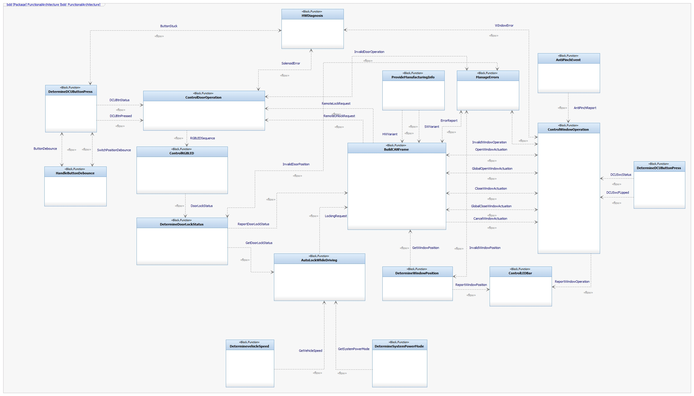
This Block Definition Diagram doesn’t specifies which Door or Window can do which Operation. Error Handler is considered separately from normal Operations. Manual and Remote operations are split into two different functionalities.

Functional Interaction
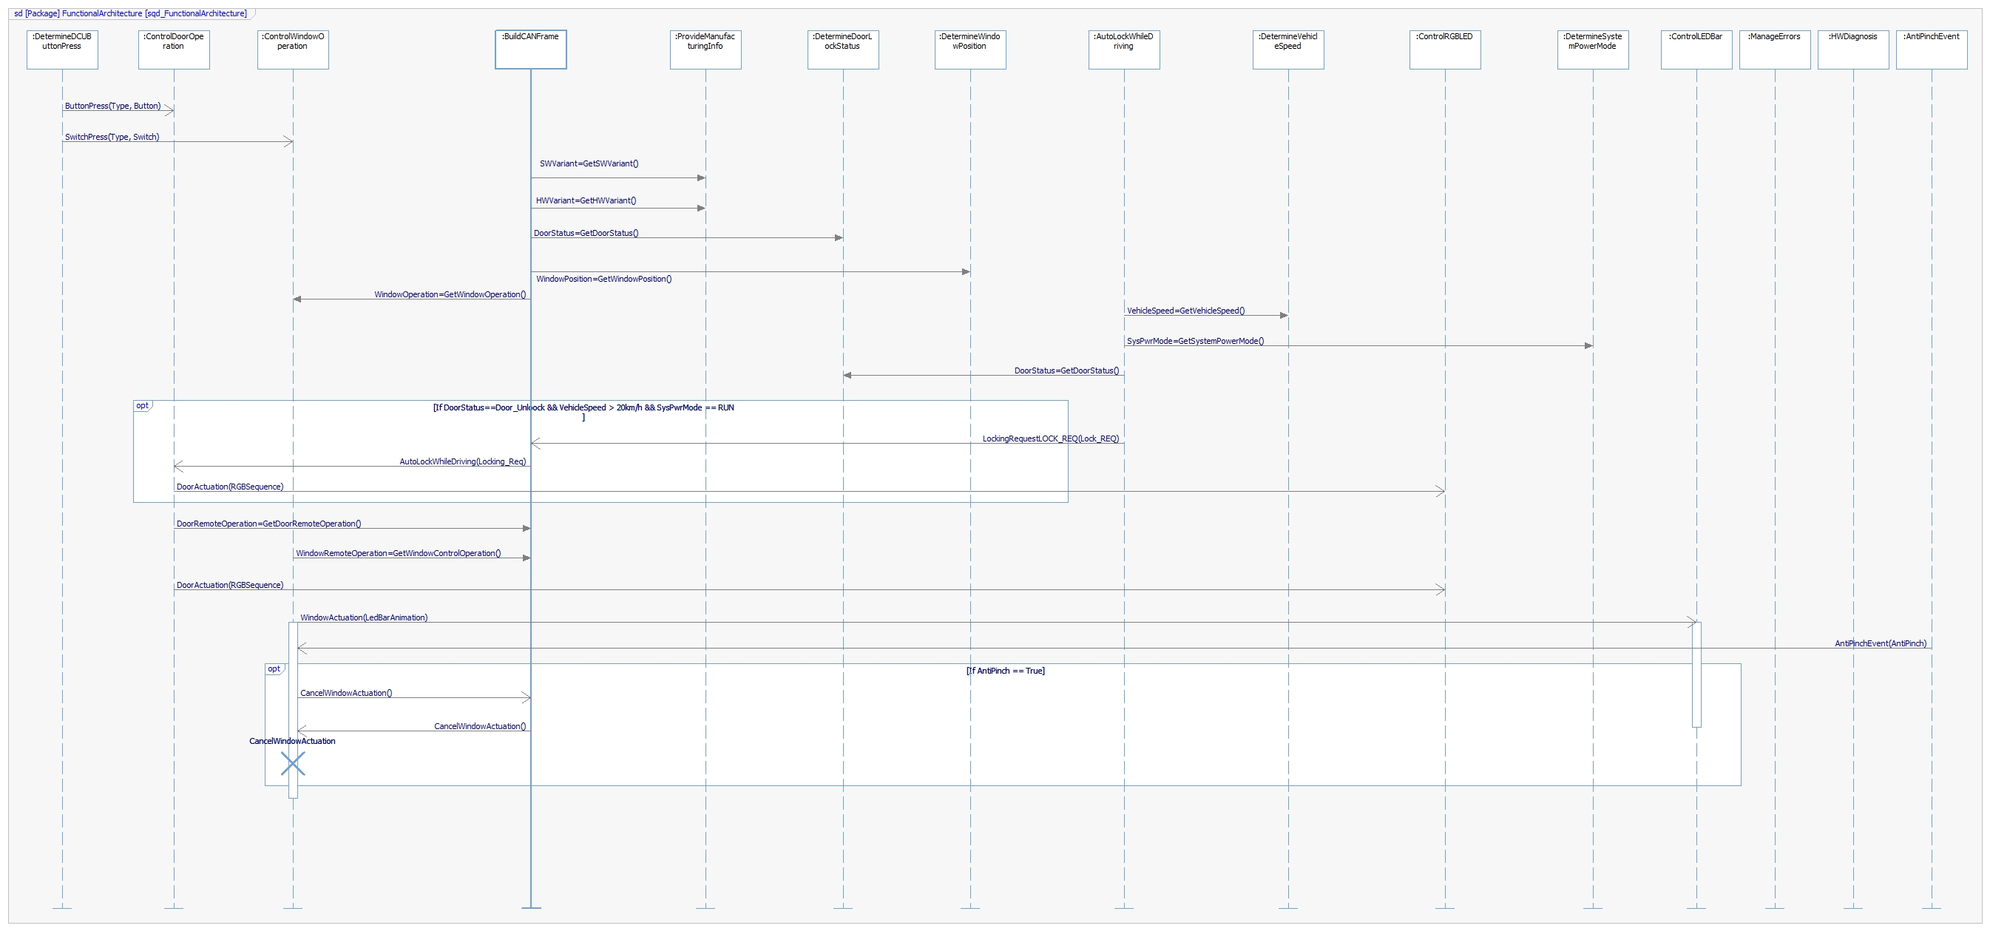

No sequence or priority is considered in the System Requirements, thus this diagram should be submitted to major changes. The current diagram is just a representation of a possible sequence that the functions might do using the suggested interfaces.

SW Physical Architecture
Define Physical architecture that will be implemented on Software with its corresponding SW decomposition.
Identify different SW Components with its corresponding interaction among them.
Identify and describe the signals and events used to share information among SW Components.

Physical Decomposition
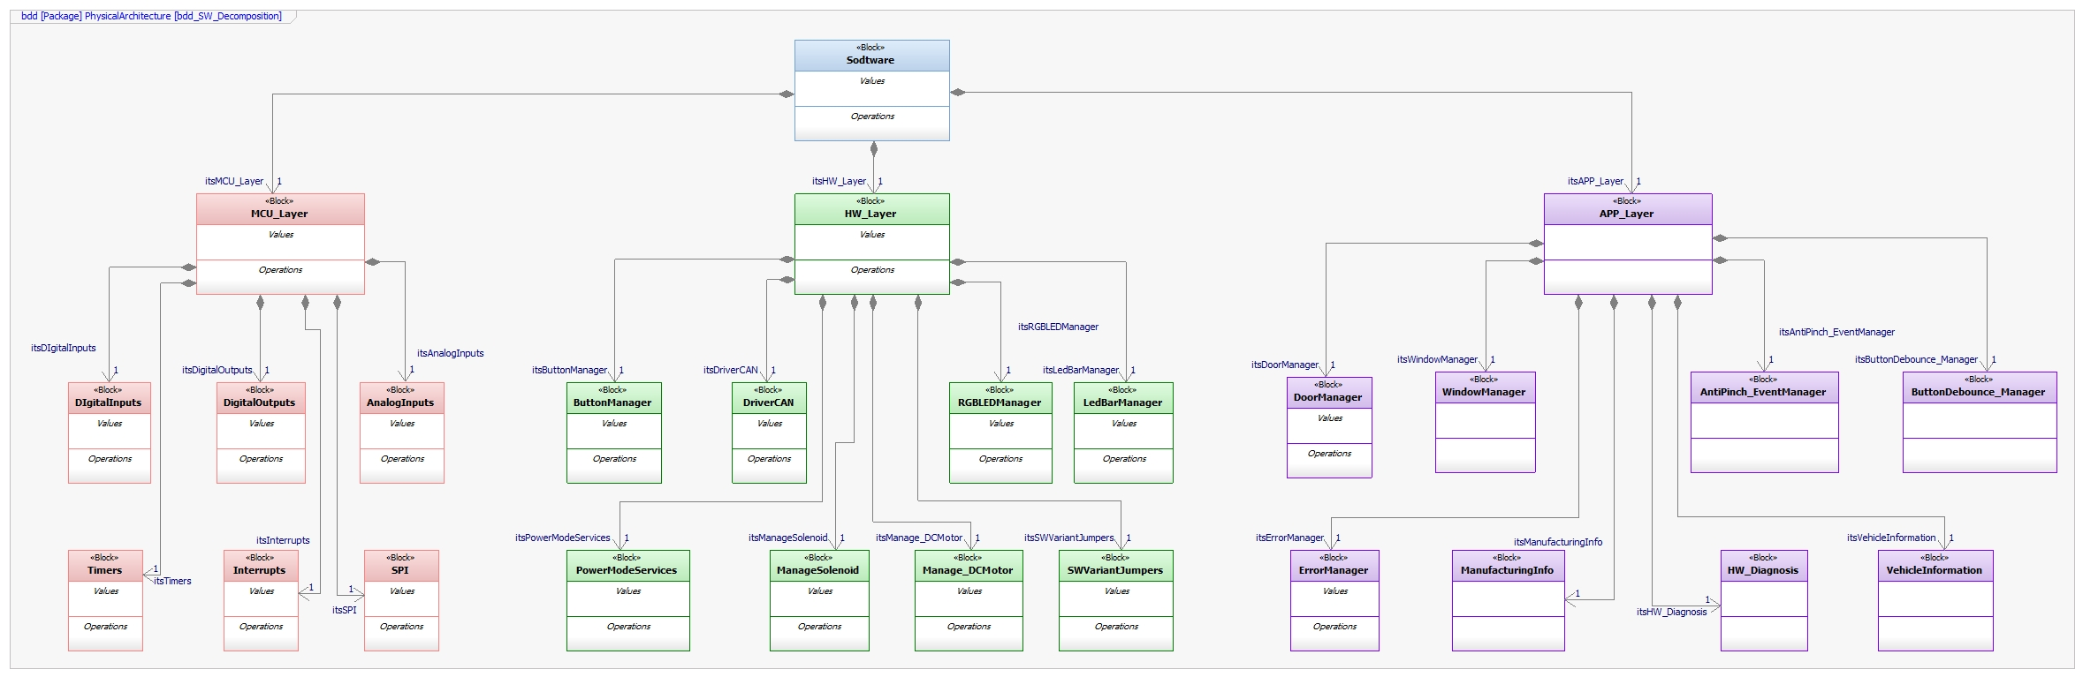
Estimated size: 50KB

Table of SW components
SWC Name | Description | Estimated Size (KB)
DoorManager | Component used for determine and report Door Position and Operation. Also performs Door Actuation. | 5
WindowManager | Component used for determine and report Door Position and Operation. Also performs Window Actuation. | 5
ButtonManager | Determines Manual Operation with Buttons and Switches press. | 4
AutoLockWhileDriving | Executes Auto Lock While Driving function under specified conditions. | 5
DriverCAN | Builds and transmits the CAN Frame. | 6
HW Diagnosis | Performs activities related to Error handling. | 4
AntiPinch_EventManager | Cancels Window Actuation if an obstacle is detected. | 4

Table of Physical Interfaces
Operation | Description
IbuttonCallback | Determines Button Manager functionalities for Door Locking.
iAutoLock | Performs Auto Auto Lock While Driving functionality.
iDoorOperation | Sets conditions to perform Door Locking Operations.
iDoorDiagnosis | Determines Door Diagnosis functionalities.
iDoorCANFrame | Sets up the CAN Frame to perform Door Operations.
iWindowInformation | Reports Window Operation and Position status.
iWindowActuation | Performs Window Operations.
iAntiPinch_Event | Performs Anti Pinch funtionality.
iSwitchCallback | Determines Button Manager functionalities for Window Operation.
iWindowDiagnosis | Determines Window Diagnosis functionalities.

Physical Interfaces
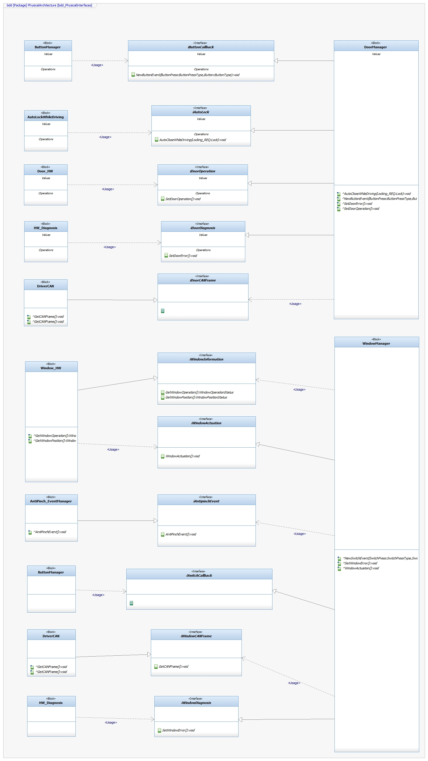

Physical Interaction

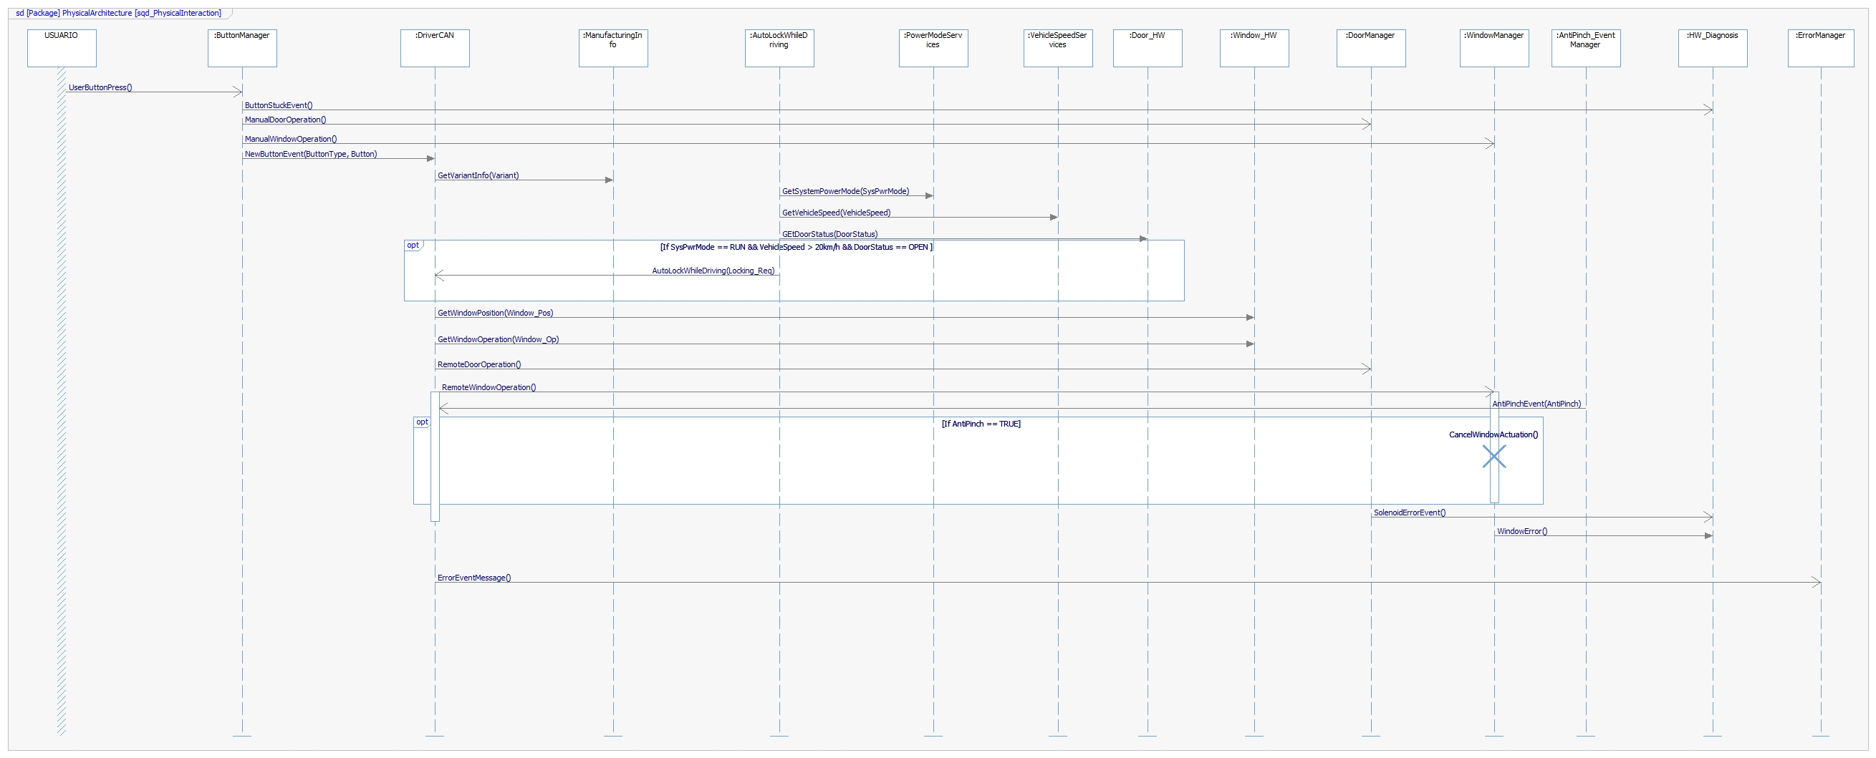

Describe Dynamic Behavior
This chapter shall be used to describe at physical level the runtime behavior of the SW.

OS tasks
OS task | Description | Periodicity | Period | Priority | CPU Load

Interrupt Handling
ISR task | Description | Priority | CPU Load

Power Modes

Low Power Mode
Describe in this chapter the operation, functions and resources that will be executed during Low Power Mode. Identify what are the wakeup sources and list them on this section.

High Power Mode
Describe in this chapter the operation, functions and resources that will be executed during High Power Mode. Identify what are the Low Power Mode conditions and list them on this section.

Synchronization Mechanisms
Describe Mechanism used to synchronize process like critical sections, semaphore, mutex, priority ceiling, etc.

Function to Physical Allocation
Perform the allocation of function to a SW component. One function shall be allocated to one SW component (if this cannot be achieved indicate a clarification wich part of the function shall be allocated to every SW component). One SW component might have
Function | SW component | Clarification

SW Requirements Allocation
Indicates the requirements that will be implemented for every SW component. Use the requirements IDs from Traceability Matrix.

SW Integration Plan
Identify the dependencies for SW construction. Identify hierarchy for implementation. Indicate the integration steps for SW construction.

Integration Step | Description | SW components | Comments

Functional Safety
This chapter will be fill during Module 5

